Computer Organization & Assembly Language
Lab 04
Topics:
- Directives ($, =, equ, textequ)
- Current Location Counter
- Signed DataTypes

- Symbolic Definitions:
A symbolic definition is created by associating an identifier (a symbol) with an integer expression or some text. Symbols do not reserve any memory storage, and their values cannot be changed at runtime. Different directives will be used to create different symbols.

‘$’ is the current location counter and it tells the current location of the variable. It returns the offset associated with the current program statement.
list db 10,20,30,40,50
listlen = ($-list)

‘Equal sign, =’ directive associates a symbol with an integer expression.
Name = expression # count = 100
Any symbol defined with the equal sign directive can be redefined in the code later.

‘equ’ directive associates a symbolic name with an integer expression or some arbitrary text.
name equ expression # a equ 2+3
name equ symbol # a equ var (var defined by = or equ)
name equ <text> # a equ <2+3>
Any symbol defined with the equ directive cannot be redefined in the same source code file.

‘textequ’ directive creates a text macro. There are three different formats:
var1 = 5
name textequ text # count textequ %(var1 * 2)
name textequ <text macro> # move textequ <mov>
name textequ %constant_expression # Copy_AL textequ <move al,count>
Any symbol defined with the directive textequ can be redefined at any time.

- Current Location Counter:
One of the most important symbols of all, shown as $, is called the current location counter.
It tells the current location of the variable and returns the offset associated with the current program statement.

my_string db “Hello World”
my_string_size = ( $ - my_string )

- Signed DataTypes:
signed data types refer to variables or values that can represent both positive and negative numbers. Unlike unsigned data types, which only store positive numbers, signed data types use one bit (usually the most significant bit, or MSB) to indicate the sign of the number
var sbyte 5
var1 sword 10
var3 sdword 20
Tasks:
- What is the difference between the directives, ‘=’, ‘equ’, and ‘textequ’?
Ans:
- ( = ) : It is used to associate a symbol with an integer expression. That symbol can be redefined again later.
- Equ : It is used to associate a symbol with an integer expression or some text. That symbol can’t be redefined later.
- Equtext : It is used to associate a symbol with an integer expression or some text. That symbol can be redefined later.
- Verify little endian order of saving variables in memory.
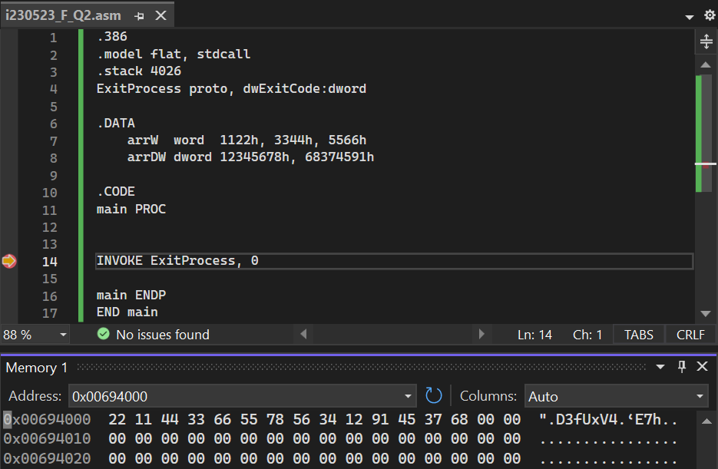
Ans: We can observe here that the values of elements of word are stored in reverse order such that the higher value is stored in high
- Declare and initialize arrays of type byte, word, double word with non-zero elements of your choice.
  - Find out the type of array and save this value in a variable.
  - Find out the length of array and save this value in a variable.
  - Find out the size of the array and save this value in a variable.
  - Find out the offset of the array and view the array in memory.
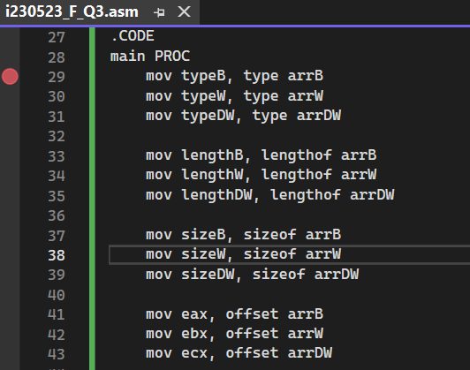
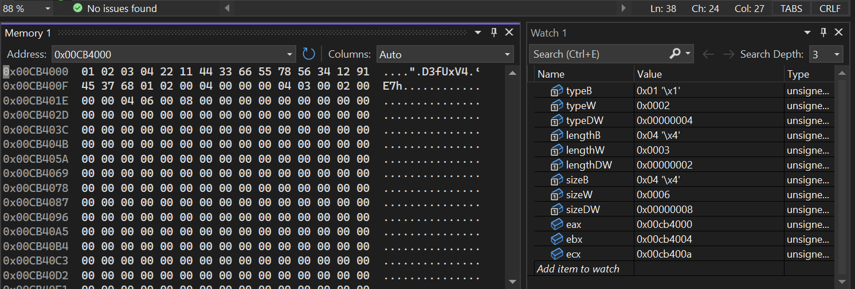
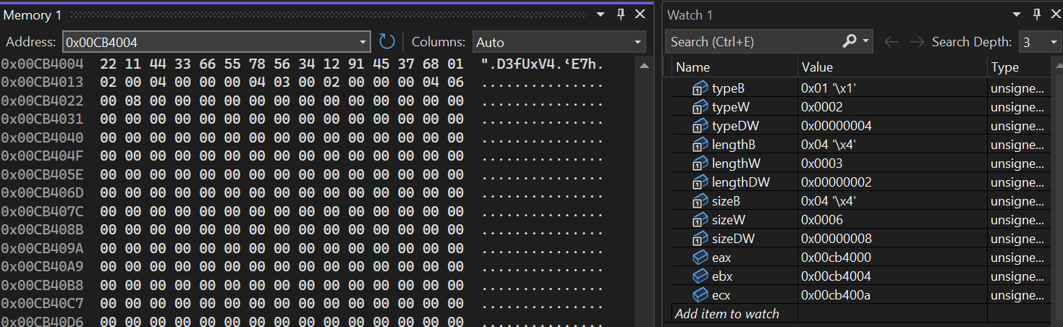
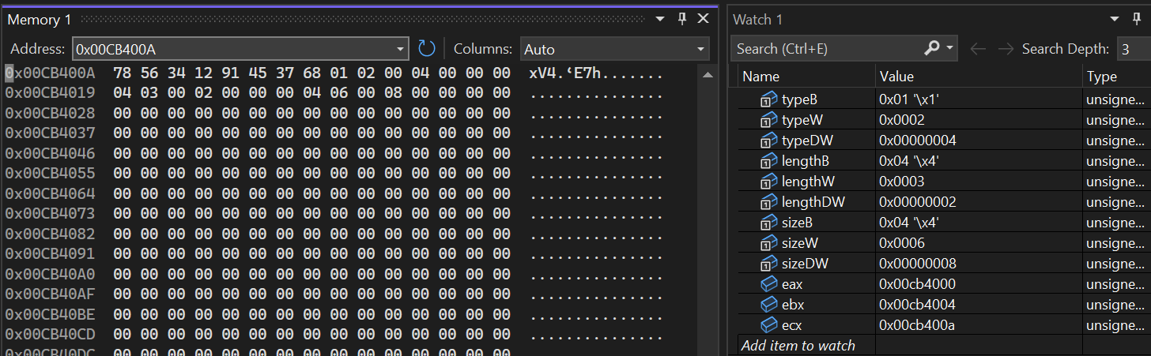
- Using the array declared and initialized in above question, you need to add any number at the even/odd indices of the array. (even/odd determined based on your roll number.)
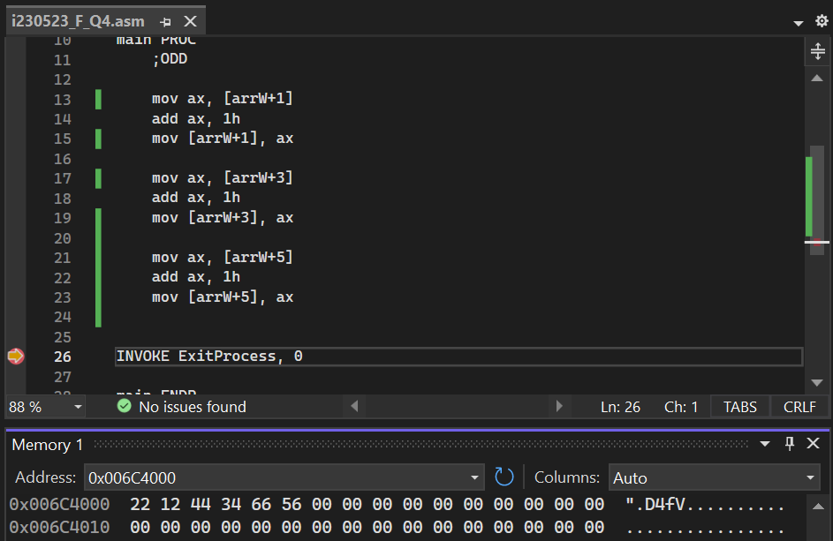
- Using the array in question 2, replace an element in array at the index based on the last digit of your roll number by a variable. View the new array in memory.
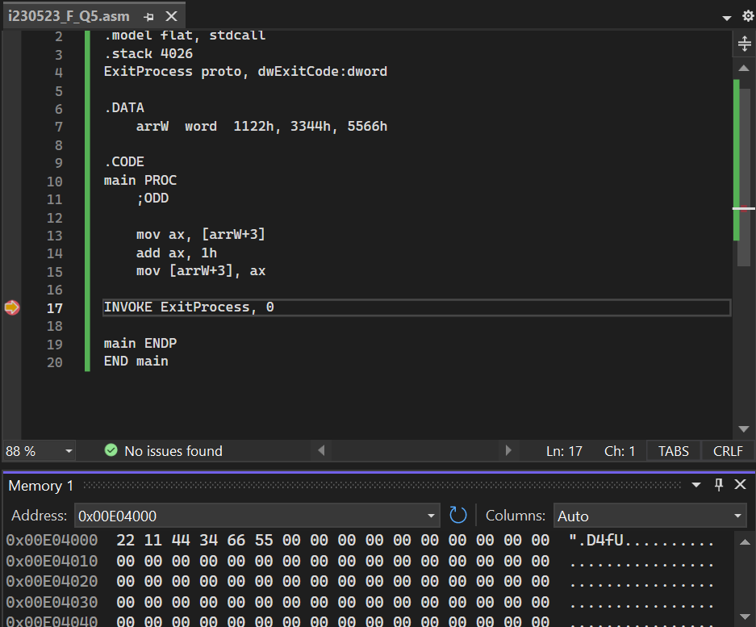

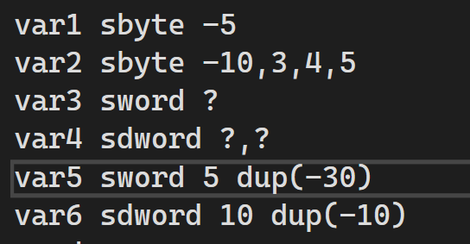
Fill the memory after execution and also write which format the it is saved in your computer (little endian).
 | 01 | 02 | 03 | 04 | 05 | 06 | 07 | 08 | 09 | 0A | 0B | 0C | 0D | 0E | 0F
0000 | FB | F6 | 03 | 04 | 05 | 00 | 00 | 00 | 00 | 00 | 00 | 00 | 00 | 00 | 00
0010 | E2 | FF | E2 | FF | E2 | FF | E2 | FF | E2 | FF | F6 | FF | FF | FF | F6
0020 | FF | FF | FF | F6 | FF | FF | FF | F6 | FF | FF | FF | F6 | FF | FF | FF
0030 | F6 | FF | FF | FF | F6 | FF | FF | FF | F6 | FF | FF | FF | F6 | FF | FF
0040 | FF | F6 | FF | FF | FF
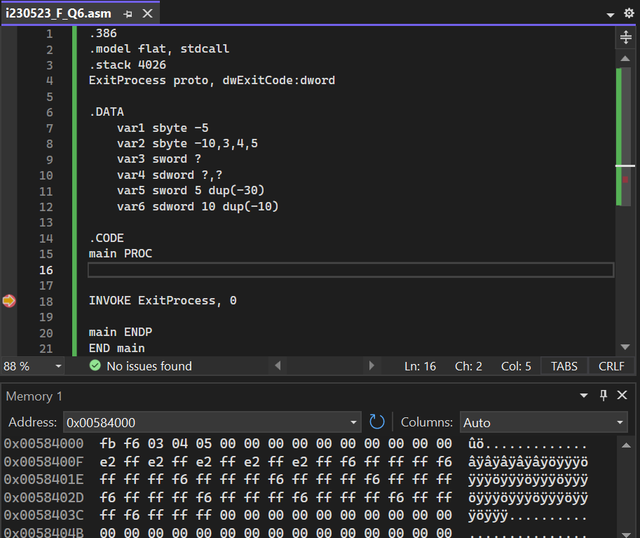
- 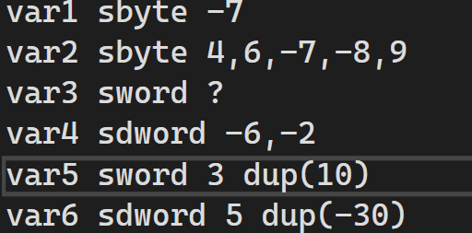
Fill the memory after execution and also write which format the it is saved in your computer(little endian).
 | 01 | 02 | 03 | 04 | 05 | 06 | 07 | 08 | 09 | 0A | 0B | 0C | 0D | 0E | 0F
0000 | F9 | 04 | 06 | F9 | F8 | 09 | 00 | 00 | FA | FF | FF | FF | FE | FF | FF
0010 | FF | 0A | 00 | 0A | 00 | 0A | 00 | E2 | FF | FF | FF | E2 | FF | FF | FF
0020 | E2 | FF | FF | FF | E2 | FF | FF | FF | E2 | FF | FF | FF
0030
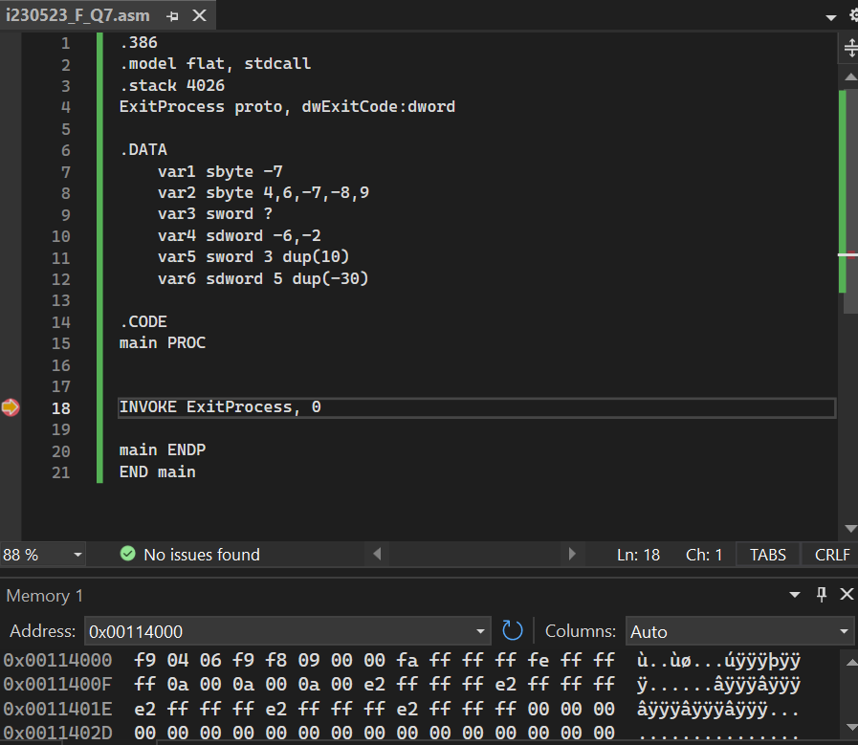

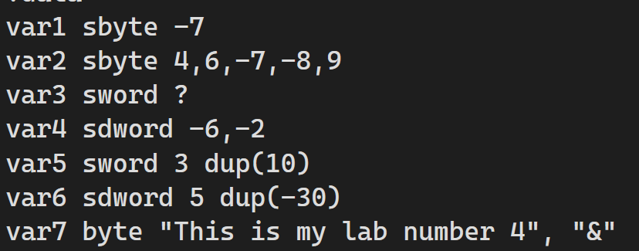

- Fill the memory after execution and also write which format the it is saved in your computer (little endian).
 | 01 | 02 | 03 | 04 | 05 | 06 | 07 | 08 | 09 | 0A | 0B | 0C | 0D | 0E | 0F
0000 | F9 | 04 | 06 | F9 | F8 | 09 | 00 | 00 | FA | FF | FF | FF | FE | FF | FF
0010 | FF | 0A | 00 | 0A | 00 | 0A | 00 | E2 | FF | FF | FF | E2 | FF | FF | FF
0020 | E2 | FF | FF | FF | E2 | FF | FF | FF | E2 | FF | FF | FF | T | h | i
0030 | s |  | i | s |  | m | y |  | l | a | b |  | n | u | m
0040 | b | e | r |  | 4 | 26

